

User Guide

For technical support call (800) 374-7488 or getTechSupport@crsdata.com
Monday – Friday 9 a.m. to 5 p.m. est.
For information about services offered through Courthouse Retrieval Systems
contact us at (800) 374-7488 or getInfo@crsdata.com

TABLE OF CONTENTS

OVERVIEW……………………………………………………………………. 2

INSTALLATION ……………………………………………………………… 3

GETTING STARTED………………………………………………………… 3
LOCATING CRSDATA ON INTERNET ……………………………………………………………….3

SEARCH OPTIONS…………………………………………………………. 5
PROPERTY SEARCH MENU……………………………………………………………………..... ..5
SORTING THE DATA………………………………………………………………………………...6
SEARCHING THE DATA…………………………………………………………………………….6
USER SETTINGS……………………………………………………………………………………...10

WORKING WITH THE SEARCH RESULTS………………………….11
PROPERTY SEARCH RESULTS SCREEN………………………………………………..………..12
MARKING RECORDS………………………………………………………………………………..12
MORTGAGE SEARCH RESULTS SCREEN………..………………………………………….…... 14
SALES SEARCH RESULTS SCREEN…………………………………………………………..….. 14
VIEWING SCREENS OF INDIVIDUAL RECORDS……………………………….………….…… 15

SIMILAR PROPERTIES FEATURE…………………………………… 20

EXPORTING/LABELS……………………………………………………..21
PRINTING LABELS…………………………………………………………………………………..21
EXPORTING LABEL INFORMATION……………………………………………………………...21
MAIL MERGE WITH MS WORD 2000……………………………………………………………...23
MAIL MERGE WITH MS WORD XP………………………………………………………………..24
IMPORTING INTO MICROSOFT EXCEL…………………………………………………………..25
IMPORTING INTO TOP PRODUCER 7i…………………………………………………………….25

TIPS FOR SORTING & SEARCHING………………………………… 26

TECHNICAL SUPPORT………………………………………………….. 26

OVERVIEW

The CRS web site was designed to give you yet another means of using the property information provided by Courthouse Retrieval System, Inc. (CRS) CRS has been listening to the suggestions and comments from our clients. This Internet product is a direct result of this communication. The Internet has opened up many more avenues of providing you the information you need the way you want it.

As with all of our services, we welcome any comments or suggestions you might have once you begin using the CRS web site. We want your experience with the CRS web site to be a pleasant one, so feel free to email us while online if you have questions or comments. You can also call us or write us with the information below:

Courthouse Retrieval System, Inc.
6700 Baum Drive, Ste. 12
Knoxville, TN 37919

Ph. (865) 584-8017 (Knoxville Metro Area)
(800) 374-7488 (Toll Free)
Fax (865) 584-8047

You can email us from the web site at getinfo@crsdata.com

INSTALLATION

CRS is a website for use with Internet Explorer. The programs you would need to install in addition to Internet Explorer are Abode Acrobat Reader 5.0 or higher, Autodesk Mapguide and CRSWeb.
All three programs can be downloaded from our website or installed via CD-ROM by an area representative.

To download Abode Acrobat Reader, go to http://www.adobe.com/prodindex/acrobat/readstep.html
To download Autodesk Mapguide, go to http://www.crsdata.net/maps/install/MGAX_mc50.exe
To download CRSWeb, go to http://www.crsdata.net/addicon.asp

A password is required to use the Courthouse Retrieval System website. To obtain a password, contact us toll free at 1-800-374-7488.

GETTING STARTED

LOCATING CRSDATA.NET WITH INTERNET EXPLORER

Open Internet Explorer and type our web address HTTP://WWWCRSDATA.NET in the address bar. (shown below):

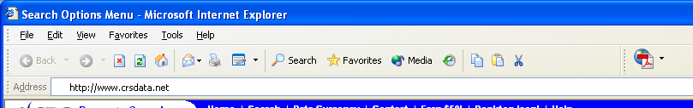

On our Home Page click MEMBERS from the menu on the left to enter the system.
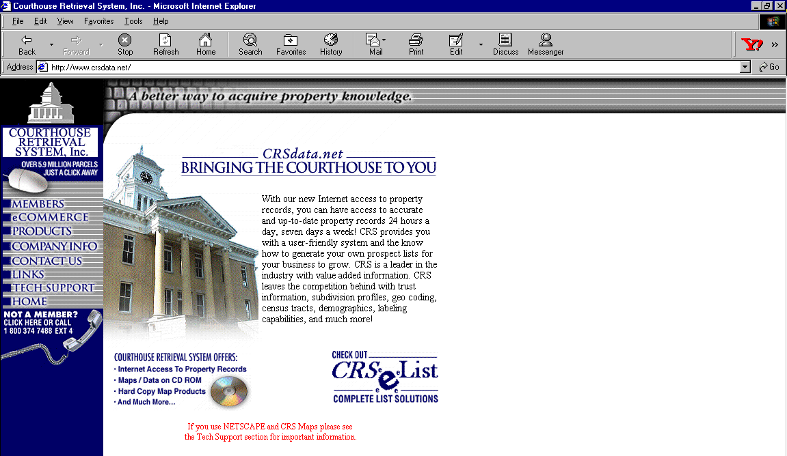
If the below screen displays, contact us toll free at 1-800-374-7488 to obtain a password.
A password is required to use the Courthouse Retrieval System website.

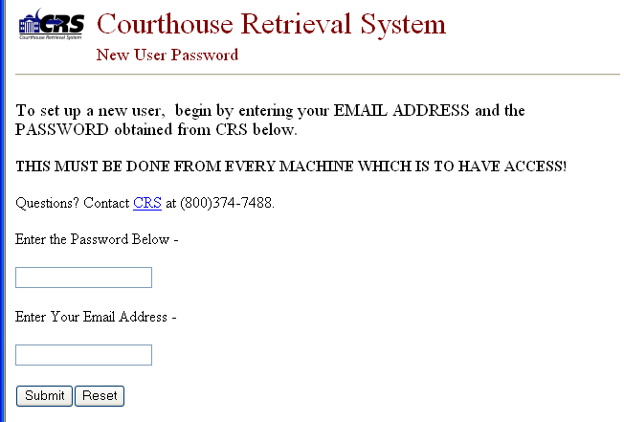

Additional Notes
- The Courthouse Retrieval System was designed for use with Windows PC computers using the Microsoft Internet Explorer browser. Some features of Courthouse Retrieval System Web site is NOT compatible with Apple computers or any other operating system or Web browser other than Microsoft Internet Explorer. The CRS Web site also requires the use of browser cookies. If you encounter problems with the system, check your Internet Explorer settings to make sure third party cookies are not being blocked. If you are unsure, set all Internet Explorer browser settings to Default.

- Software such as personal firewalls, pop-up blockers, or privacy features may interfere with the Courthouse Retrieval System Web site functionality.

PROPERTY SEARCH MENU

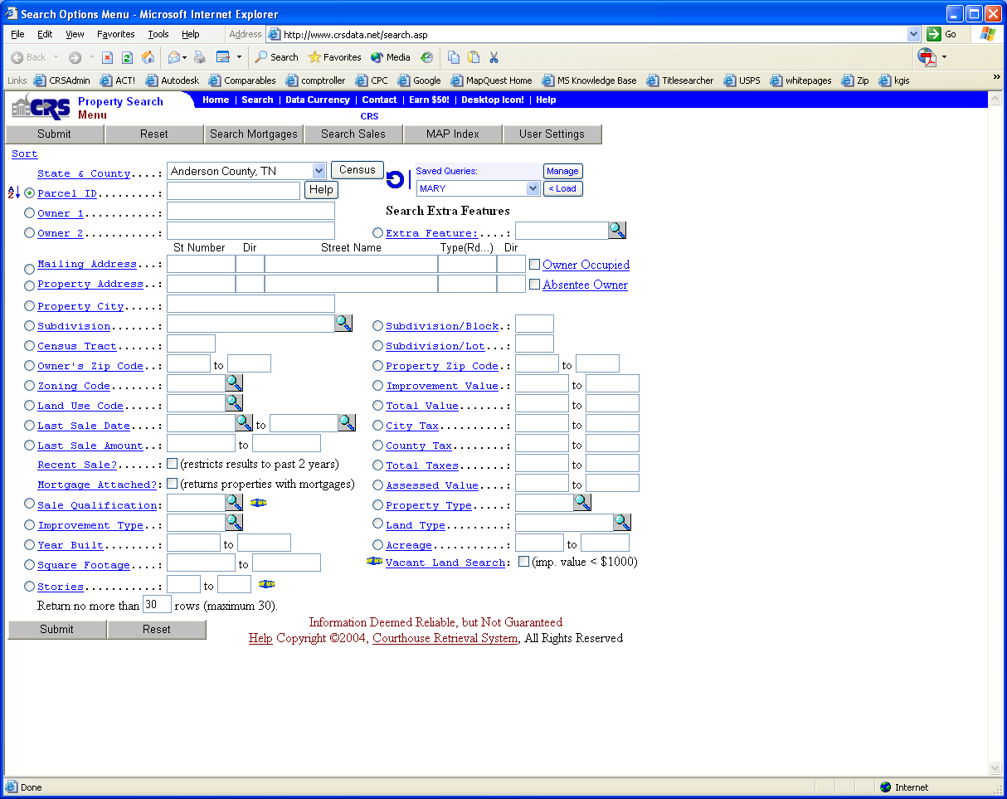

Here you will find the source for all of your sorting and searching needs. Important parts of the screen to note are:
Click on the button once you have selected your search and sort criteria.
Click on the button to clear all of the fields

NOTE: Mortgage searches are a premium service provided to CRS mortgage clients at an additional cost. MAAR
did not order this service so you will not see this button on your screen.


Gives you the Trust Deed Search Options Menu
Takes you to the search options menu for Recent Sales information. These include parcels that have resulted from either a large parcel being split into smaller parcels or two or more parcels being joined together from a single larger parcel. Many times this results in missing parcel id’s in the regular data.


Opens the User Configuration Editor that allows you to customize settings that determine how you view and print the information. See “Customizing Options for CRS”

You will notice the dot to the left of each of the fields in the menu. This is your Sort option. See “Sorting” later in this section or click on the Sort link for more information.

Each of the three search menus has the same layout to simplify the search process. The data fields are listed with a space to the right for entering your search criteria. For help on a specific field, click on the field names. This is a link to helpful information related to that specific field of information. The following are each of the search menus available.

SORTING THE DATA

The sort option is activated by clicking the circle next to the field you want to sort on so that the circle has a dot inside of it. The default sort is by parcel id. A over Z will be ascending order and Z over A is descending order. To change the order, click once on the A over Z or the Z over A.

Note: The sort is independent of the search. In other words, you can sort a field and then enter search items on another field. For example: If you are searching a Subdivision you will probably want to click the sort dot beside address to get a list of all the properties in a subdivision sorted by address. If you are searching for a particular address, there is probably no need to sort. Just type in the partial address information and submit.

Remember… if your search is likely to return only one or two records then there is no need to change the sort. In a case like this, leave the sort dot where it defaults to (parcel id).

SEARCHING THE DATA

Property Search Menu

County Selection – this contains a pull-down list of the counties you are authorized to use.

Parcel ID – enter partial map & parcel information to retrieve certain areas of a county.
For example, most counties in Tennessee you would enter with this
Template = MMMMMGGPPP.PP
Example: To find parcel 003.01 in group C of map 123A you should type: 123A(space)C(space)003.01

Important: The above example applies to most Tennessee parcels. Examples for specific counties can be obtained by clicking on the HELP button next to the Parcel ID search option at the main search screen.

Owner1 & Owner2 – search for owner names last name first. Example: Smith John Enter a space between the names, NO Comma

Mailing & Property Addresses – enter partial address information to locate certain properties. Since your chances of matching exactly what was entered at the courthouse are slim, you need to keep this search as broad as possible. For example: if I need to find 1304 Deer Circle, I would put “1304” in the Street Number and just “Deer” in the street name. The person at the courthouse might have abbreviated “Circle”, since you can’t be sure, don’t include it at first. If your results give you too many variations, such as Deer St, Deer CV, etc., look to see how they have entered “Deer Cir” and go back to the Search Options Menu and refine your search.

Subdivision – enter name of subdivision to locate.

Owner’s ZipCode – enter one (enter same # in both spaces) or a range of zip codes.

Zoning Code – three digit census code that is assigned to an area by the U.S. Census for collecting information.

Land Use Code – the present use of the property (not zoning) Click on List to view the codes for the selected county.

Improvement Type – the type of structure(s) that exists on the property. Click on List to view types for selected county.

Last Sale Date – enter full digits and forward slashes for the date. Ex: 01/01/99 or 12/05/97 – There is a beginning date and ending date range available here.

Last Sale Amount – enter one amount in both spaces or enter your range lower amount in the first space and higher amount in the second space. Note: Amounts are rounded to the nearest dollar amount.

Acreage – size of the property – you can enter a range here also, to search for properties within a high and low amount.

Square Footage – the square footage of properties on the property - range is also available.

Recent Sale? – marking the box with your mouse will limit your search to sales that occurred in the past two years.

Return no more than 30 rows at a time – you can adjust the list of summary data to suit your preferences. By default the records will list 30 at a time in the Search Results screen.

Extra Feature*** – searching on extra features such as mobile homes, pools, etc.

Property Zip Code – enter one zip code (same # in each box) or enter a range of codes.

Imprvmt Value*** – dollar amount of property improvements. You can enter a range of amounts here. Note: Amounts are rounded to the nearest dollar amount.

Total Value*** – total value of property including improvements. You can enter a range of values.

City Tax*** – city tax amount. Dollar amount rounded to the nearest dollar. You can enter a range of tax amounts.

County Tax*** – county tax amount. Dollar amount rounded to the nearest dollar. You can enter a range of tax amounts.

Total Taxes*** – total tax amount on a property, including city and county taxes. You can enter a range of dollar amounts here.

Assessed Value*** – assessed value of a property. Dollar amount rounded to the nearest dollar. You can enter a range of amounts.

Year Built*** – four digit year that the building was built. (Ex. 1995) You can enter a range of years here.

New fields are added for better searching. If a field on the Property Search Menu isn’t listed here click the name of the field to get a description of it.

*** If you search or sort on any of these items they will be included on the Search Results Screen.

Once you have completed your sort and search criteria, click on the SUBMIT button. The Search Results Screen appears and you can begin viewing the data. RESET will clear all fields to begin a new search.

Mortgage Search Menu

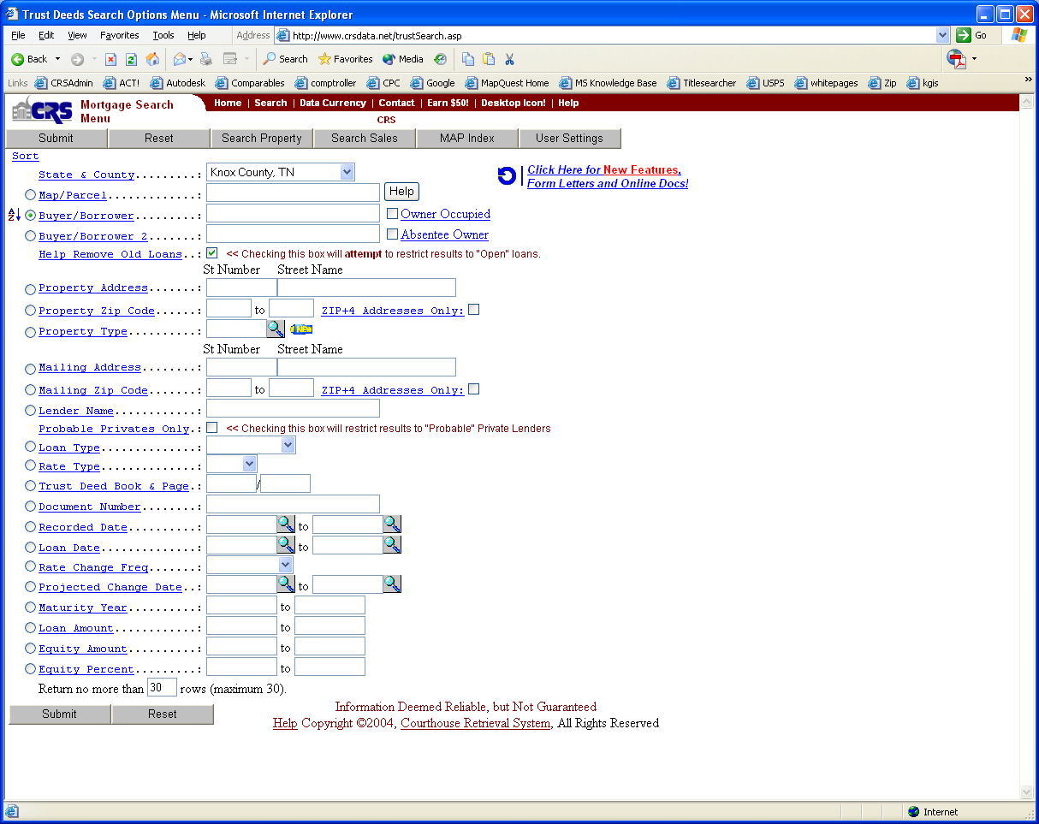

By clicking on the Search Mortgages button, the fields relating to trust deeds are available for you to search
and sort:

Map/Parcel – search on map numbers and parcel numbers to look at specific areas.

Buyer/Borrower(& Buyer/Borrower2) – enter the name of the buyer / borrower.

Mailing/Property Address – enter partial address information to locate certain properties.

Mailing Zip - enter one (enter same # in both spaces) or a range of zip codes.

Lender Name – enter the lender name you are searching for.

Loan Type – (FHA/VA) to search for a specific loan type.

Rate Type – (FIXED/ARM) to search for a specific rate type.

Trust Deed Book and Page – enter the book number in the first box and the page number in the next box.

Loan Date – you can enter a range of dates, or a single date. (enter same date in both fields for one date)

Change Date – the date the interest rate changes. You can enter a range of dates, or a single date. (enter same date in both fields for one date)

Loan Amount – you can enter a range of amounts or a single amount. (enter same amount in both boxes for one amount).

New fields are added for better searching. If a field on the Mortgage Search Menu isn’t listed here click the name of the field to get a description of it.

Once you have completed your sort and search criteria, click on the SUBMIT button. The Search Results Screen appears and you can begin viewing the data. RESET will clear all fields to begin a new search.

Sales Search Menu

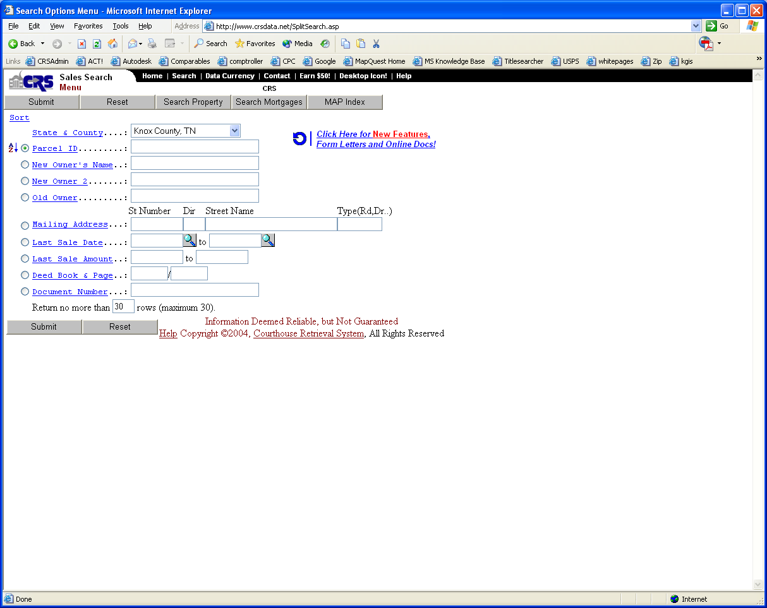

By clicking on the Search Sales button from the Property Search Menu the above screen appears. Here you will find the search options for finding parcels that have resulted from parcel splits or combining of parcels into a single parcel.

Parcel ID – enter partial map & parcel information to retrieve certain areas of a county.

New Owner & New Owner2 – search for owner names last name first. Example: Smith John Enter a space between the names, NO Comma

Old Owner - search for previous owner’s name last name first. Example: Smith John Enter a space between the names, NO Comma

Mailing Address - enter partial address information to locate certain owners.

Last Sale Date – enter a single month (in both spaces ex: 12/96 and 12/96) or enter a range of months (10/96 and 12/96).

Last Sale Amount – enter one amount in both spaces or enter your range lower amount in the first space and higher amount in the second space. Note: Amounts are rounded to the nearest dollar amount.

Deed Book and Page – enter the book number in the first box and the page number in the next box.

New fields are added for better searching. If a field on the Sales Search Menu isn’t listed here click the name of the field to get a description of it.

USER SETTINGS -USER CONFIGURATION EDITOR

This feature is available on the Property Search Menu. This screen gives you the ability to change the way you view and print the data.

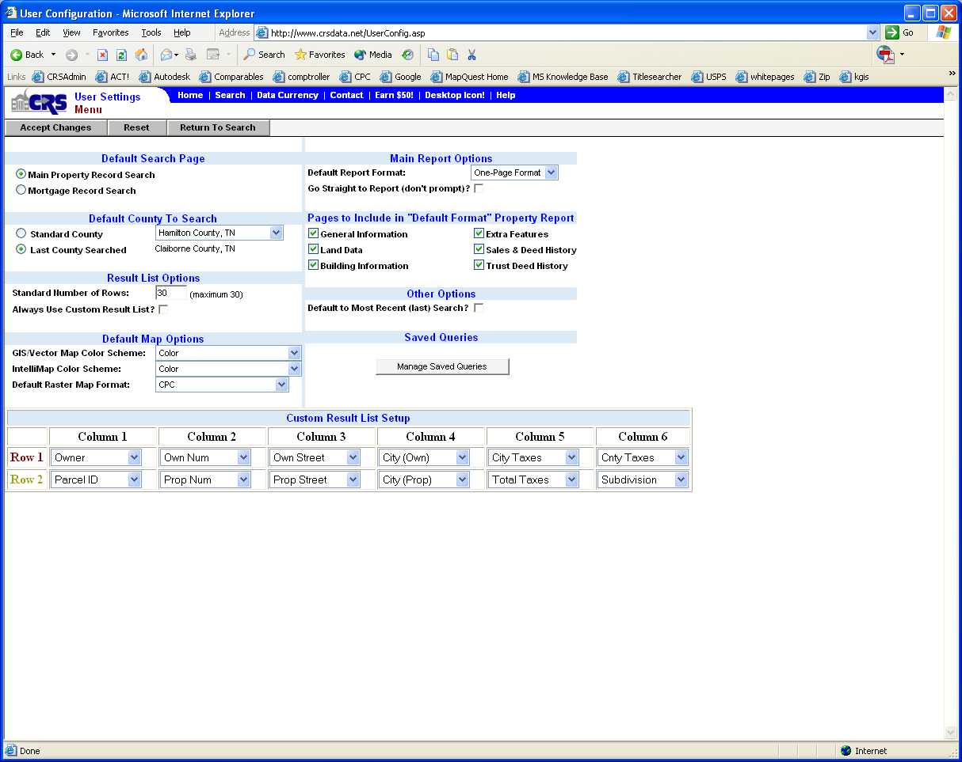

Default Search Page
When the CRS website is opened, whether through the icon or typing www.crsdata.net, the selected search page will display.

Default County To Search
Standard County – when any search page is accessed, this county will be selected.
Last County Searched – when any search page is accessed, the last county you searched in will be the county selected.

Result List Options
Standard Number of Rows – can be a number between 1 and 30. This is the maximum number rows that are displayed on any Results page.
Always Use Custom Result List? – Check this box if you want the fields selected under the Custom Result List Setup to be displayed on the Results page instead of the Standard list (created by CRS).

Default Map Options
GIS/Vector Map Color Scheme – Color, Black and White, OR Aerial Maps (where available)
IntelliMap Color Scheme – Color, Black and White, OR Aerial Maps (where available)
Not Everyone has access to Intellimaps at this time.
Default Raster Map Format – CPC or PDF (where available)

Custom Result List Setup
On the Property Results page you can choose which fields you want to see in the columns. You can select 2 fields per column. The fields you can choose from are listed in this section. This custom list is only available on the Property Results page.
You can access this list by clicking on the Custom Result List button from the Property Results page. However the Printer Friendly button is not available for the Custom Result List.

Main Report Options
Default Report Format – Default Format, One-Page format
When you click on the Full Report from the Results page the report you choose here will be the Report selected.
Go Straight to Report (don’t prompt)? - If this box is checked you will not be asked which report you want to see after you click on Full Report. The report selected in the Default Report Format option will immediately display.

Pages to Include in “Default Format” Property Report
The sections checked will be displayed on the Default Format report.
For the One-Page report you can control the sections from the report itself.

Other Options
Default to Most Recent (last) Search? – If this box is checked the last search you did will automatically be inserted in the fields the next time you go to a search menu. The exception is if you the cookie for crsdata.net is deleted the last search will be lost.

Saved Queries
To delete or view all queries that have been saved click the Manage Saved Queries button.

WORKING WITH THE SEARCH RESULTS

Once you submit a search, a Search Results Screen will appear. This screen contains a summary of the records found according to your search criteria. It will display the number of records that you choose at the bottom of the Search Options Menu (Return no more than ## rows at a time).

The type of Search Results Screen you receive is determined by which Search Menu you were searching from…

A search from the Property Search Menu gives you the following result screen:

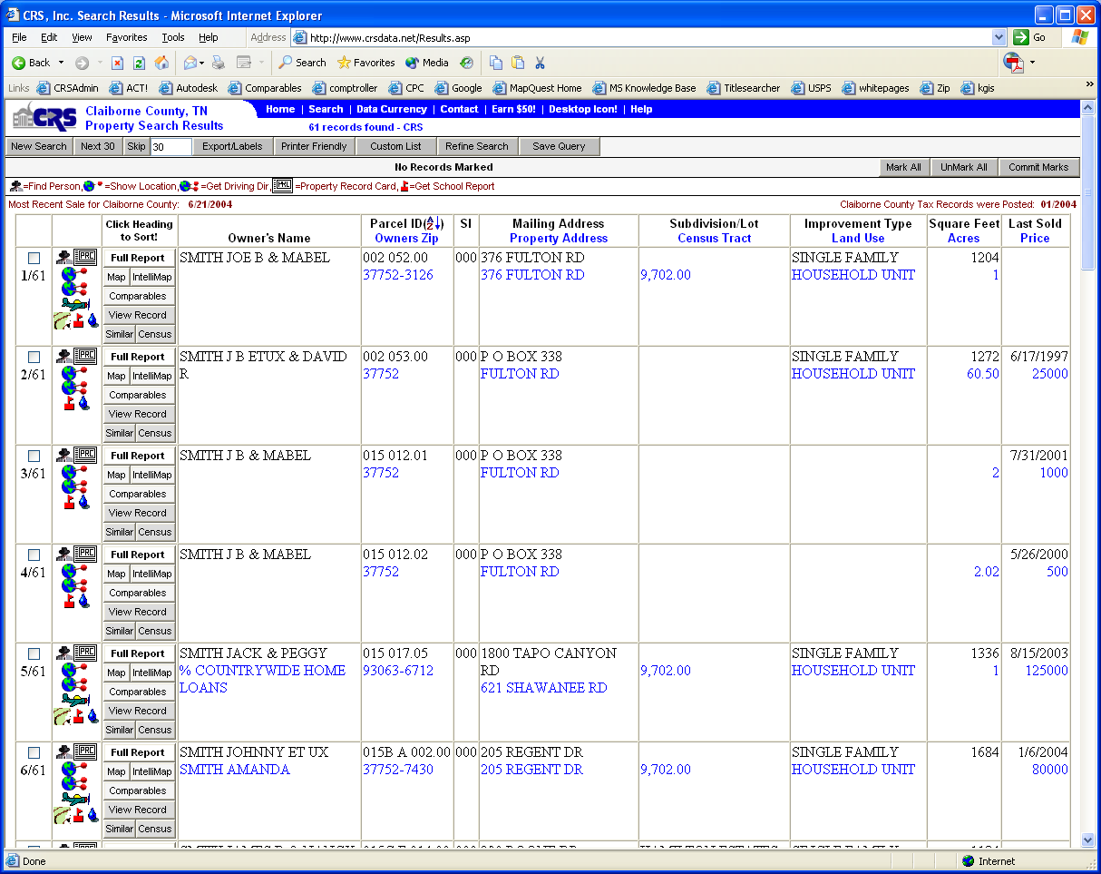

THE SEARCH RESULTS SCREEN:

Search – Returns you to the Search Options Menu.
Next ## – In the examples above, the number of “Rows to View” in the Search Options Menu was set to 30 in the Main Search and 10 in the Trust Search instead of the default value of 10.
Skip – Skip forward the number of records designated in the box to the right of the Skip button.
Export/Labels – Click here to export name and address information for use with other applications or click here to print labels.
Mark All – Marks all records in current Results List.
Unmark All – Unmarks all marked records.
Commit-Updates the number of marked records to include what has been on the current page. This is used to
accumulate records from more than one search. For example: You have just performed a search and marked two records on the current page. Now you want to perform a different search but still keep these records marked. Click the COMMIT button then click the NEW SEARCH button. You will have 2 marked records and can mark more records before you print labels or export.

Note: A View Custom List button will appear if you have defined a custom results list in the User Configuration
Editor. You can use this button to toggle between your custom results list and the default results list.

Next to each record, you will see the following:
The BOX is for marking the record. Click on the box to mark or unmark a record.

The next area shows the record number you are on and below that is the total number of records returned by your last search. In this example, we are on record 1 of 61 records.

The Full Report button - click here to view and print the details of this record in a condensed report format.

The View Record button - click here to view the details of this record.

The Map or Intellimap button – click here to view a tax map of the record.

The Comparables button – click here to view comparable properties.

The Similar button – click here to perform a comparable search.

The Census button – click here to view census details of this record.

MARKING RECORDS FROM THE MAIN SEARCH RESULTS SCREEN:

Marking records becomes a useful tool when you need to print reports or labels on several properties. There are two methods of marking records that can help you do what you need in a timely manner.

- Marking Individual Records In No Particular Order
If you can see the property on your screen in the results list, then you can mark it. Just click in the box in front of each property record that you want to mark. A check will appear in the box to reflect the “marked” status. If you click a second time in the “checked” box, the check will disappear indicating an “unmarked” record. You can hit the Next ## button to forward to the next screen of property records. At this point you will notice that a total appears at the top of the screen to show how many records have been marked as of
the last screen of records.

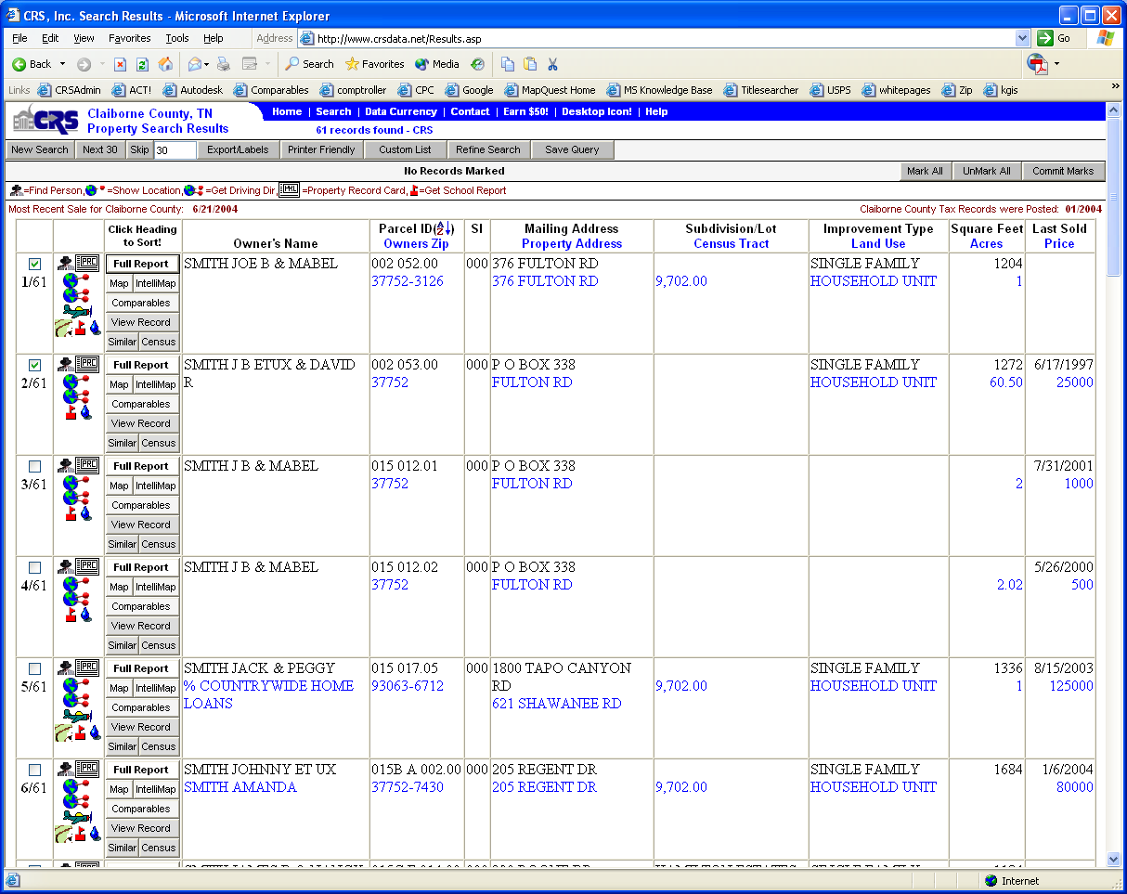

In this sample we marked 2 properties on the first screen. Now, we can either mark more records or we can choose to print our marked records. The Print Marked button allows you to print full reports for each marked record with this one button. You can export or print labels for the marked records by clicking the corresponding button.

- Marking All Records In A Results List At One Time
By clicking on the Mark All button all records in the current results list are marked. (Checks will appear in all of the boxes) You can mark many screens in minimal time with this feature. Also, if you would like all properties on one screen except for one, click on Mark All and then click on the one property you do not want. This will “unmark” the property you do not want.

Note: The Unmark All button “unmarks” ALL marked records, not just the current screen.

A search from the Mortgage Search Menu gives you this:

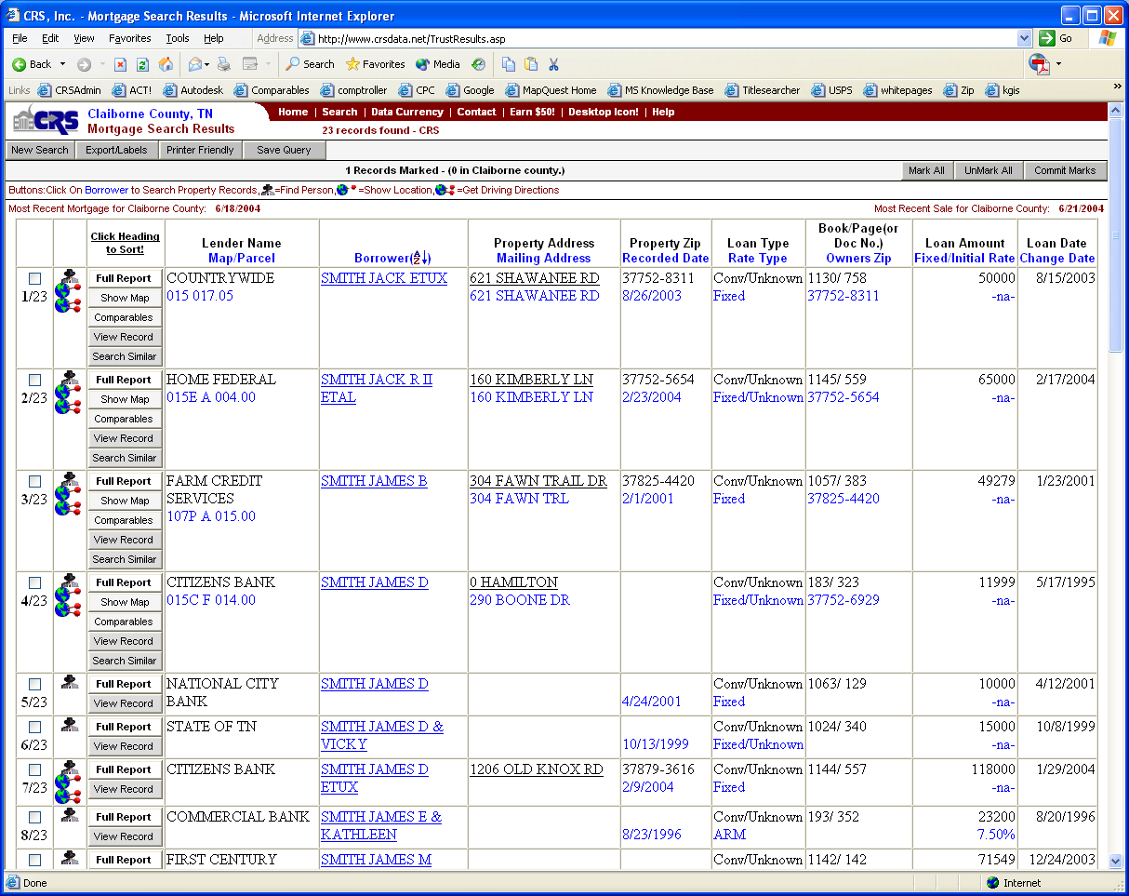

THE MORTGAGE SEARCH RESULTS SCREEN:

You will notice with this result screen you have columns of information that pertain to the trust deed such as lender name and loan amount.

A search from the Sales Search Menu gives you this:

THE SALES SEARCH RESULTS SCREEN:
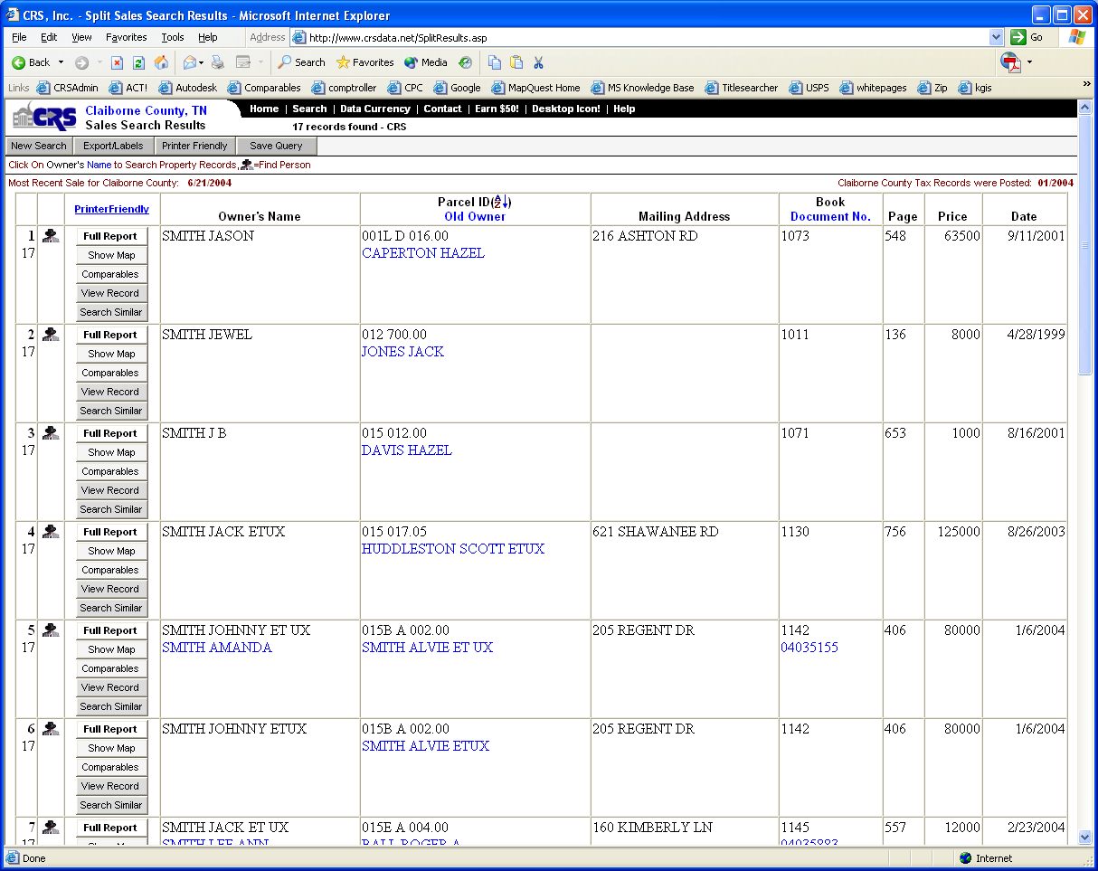

VIEWING SCREENS OF INDIVIDUAL RECORDS

Once you selected View Record to view a record from the Property Search Results Screen, the following screen appears:

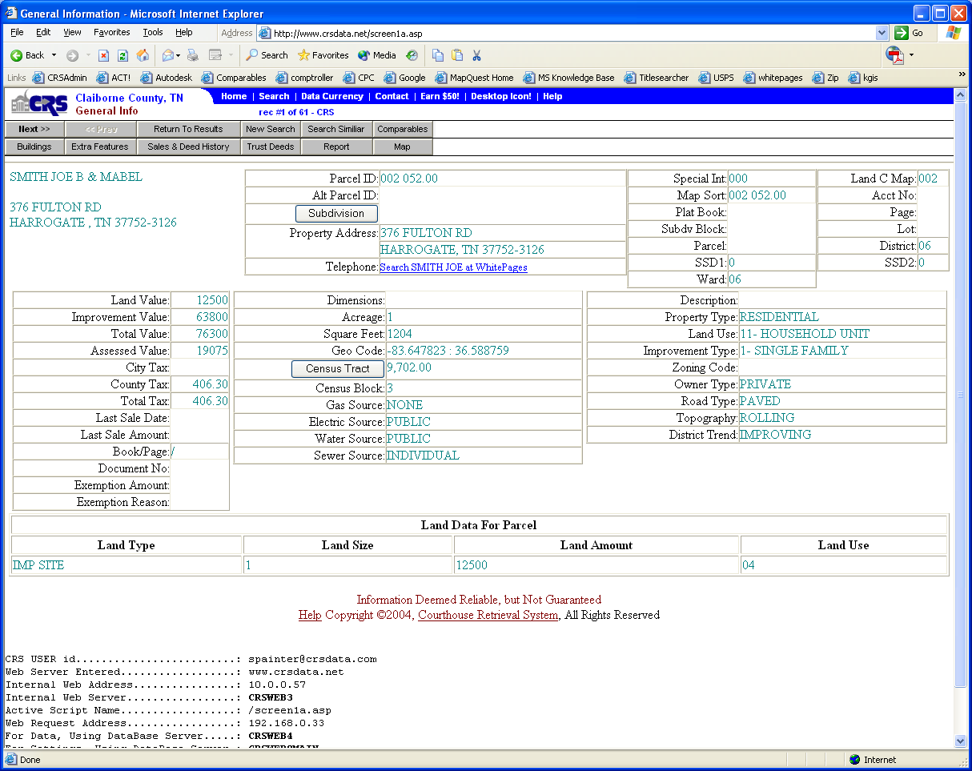

This is the first of five screens of information for this record. This is called the General Information screen. It gives the main information for the selected parcel.

Return to Results – Returns you to the previous results screen.
Buildings – To view the building information screen for this property.
Extra Features – To view the extra features screen for this property. (pools, patios, sheds, etc.)
Sales & Deed History – To view property transfers and sales for this property.
Trust Deeds – To view Trust/Mortgage information relating to this property.
New Search – Returns you to the Search Options menu to begin a new search.
Search Similar – To search for properties similar to this property. (See “Similar Properties Search Screen”)
Report – Generates a report on this property.
Map – If you have purchased CRS Maps and have your CD in the Cdrom drive, this will open the Map Navigator for the current county.
Next>> & <<Prev - Click on the arrows to go to the previous property record or go forward one record.
Comparables –Click here to view comparable properties of the subject.

Subdivision – Gives you the subdivision profile which has various statistics for that subdivision.

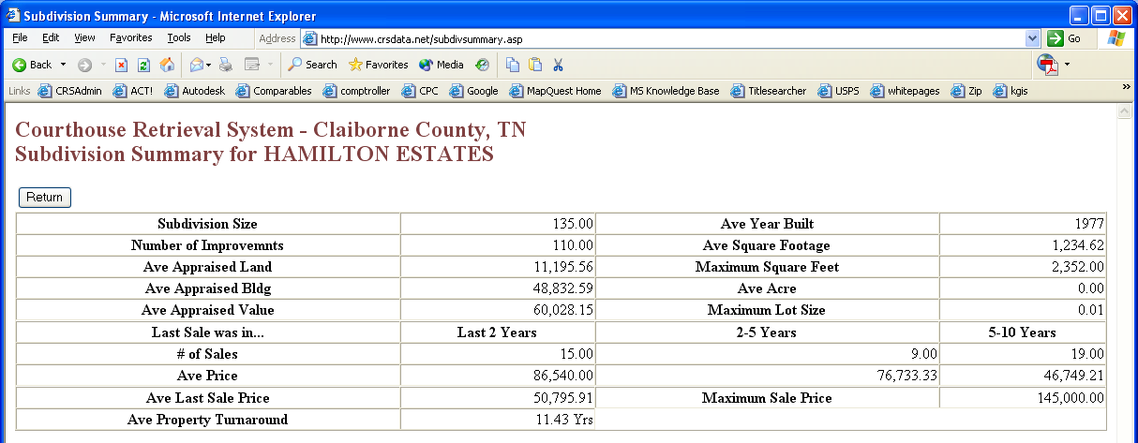

This screen gives you some important statistics about the subdivision where the viewed property is located.
If this record has a census tract number assigned to it, you can click on this button to view census data.

The Census Data Selection Menu (shown below) gives you a broad range of search options for finding out census information. Information from the current property being viewed is automatically inserted into the fields. This way you can retrieve census information specific to this property. However, you can change the fields to retrieve a much broader level of census information such as a county or a metro area.

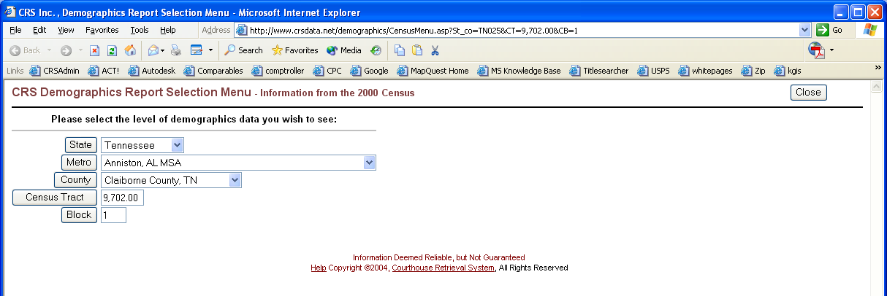

Choosing View Record button from the Mortgage Search Results Screen takes you right to the trust information screen first:

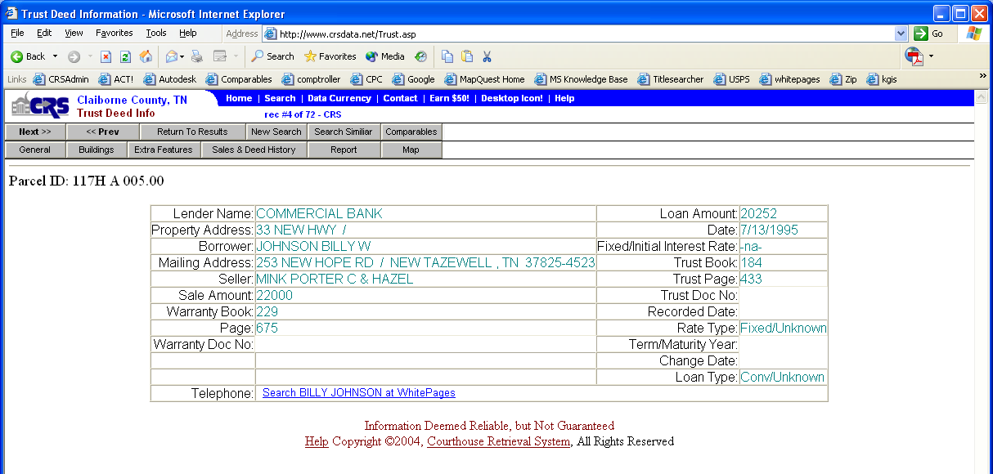

**NOTICE: When searching from the Mortgage Search Options Menu, you will find all trust deeds collected by Courthouse Retrieval System, Inc. At times, actual trust deeds in the courthouse do not contain enough information to match them to a property. When this happens, we collect as much of the information as possible and add it to our trust deed database. These “stand alone” trust deeds appear in our database just as trust deeds that could be attached to a property. The difference you will see is on the “stand alone” trust deeds, there will be no other screens available for that record. The buttons for General Information, Buildings, Extra Features, Sales & Deed History will not appear.

The following are the remaining screens of information you will find for each property:

Buildings screen (Click on the corresponding button to access each screen):

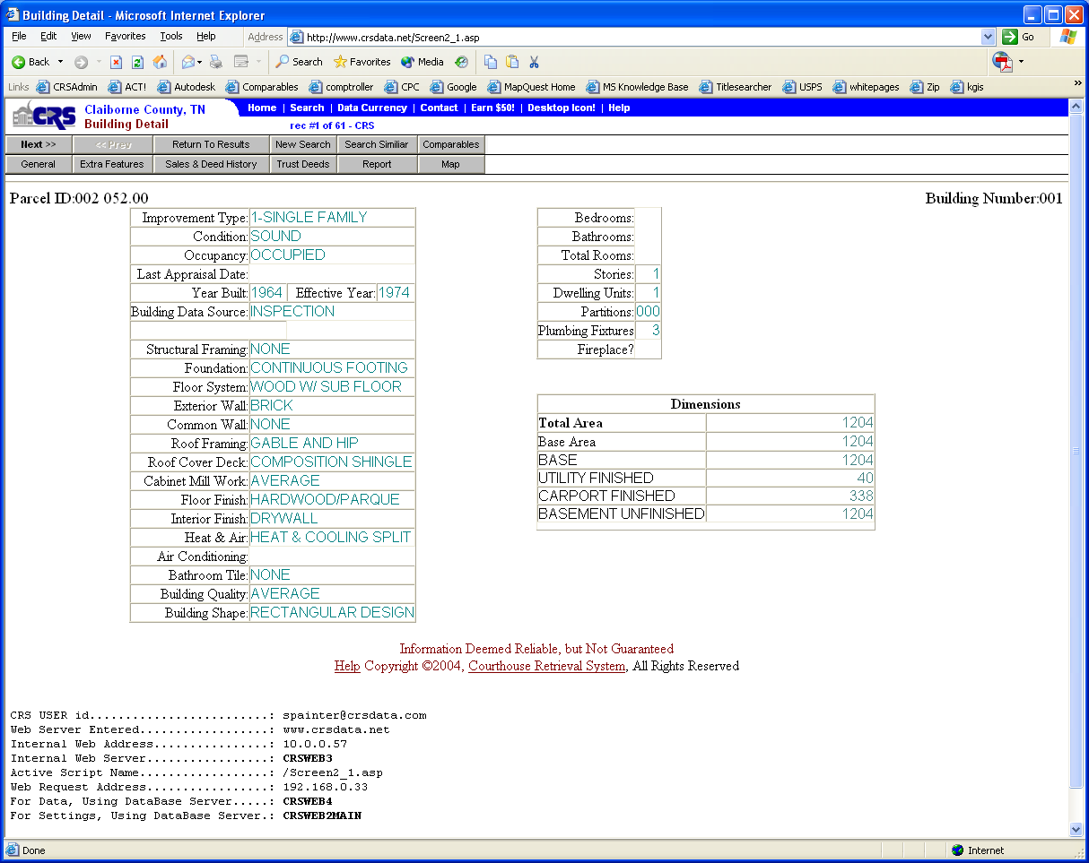

This screen provides detailed information about each structure located on the property. If applicable, additional information is provided about basements, unfinished utility areas, and carports, etc.

Extra Features screen:

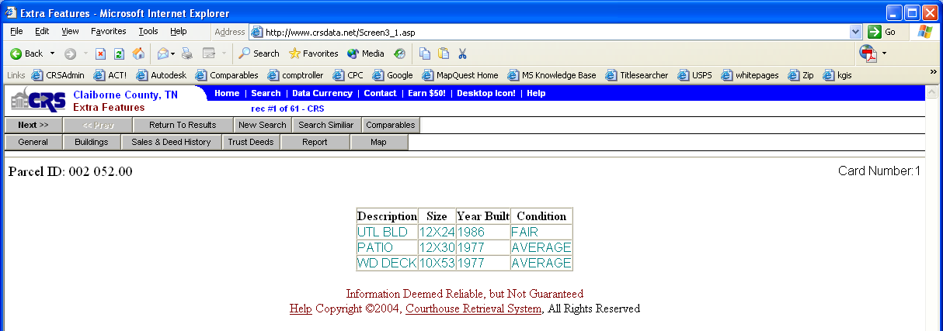

This screen provides additional information about the property that is not included in the description or square footage. Information can be additional structures on the property such as pools, stoops, chicken coops. Square footage of these structures is not included in measurement of the buildings. Note: You can search on these features from the main Search Options Menu.

Sales and Deed History screen:

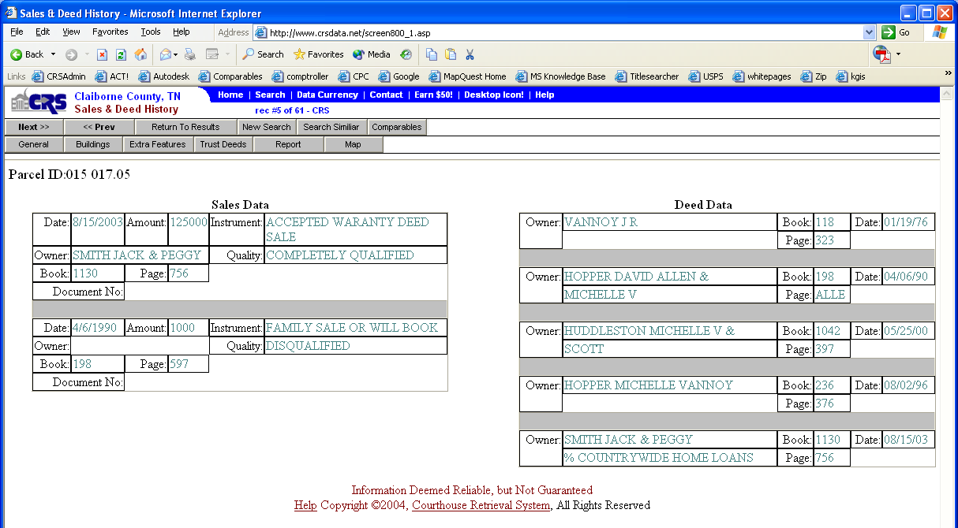

This screen provides information about the sales history or the deed history for this property.

Trust Deed Screen:
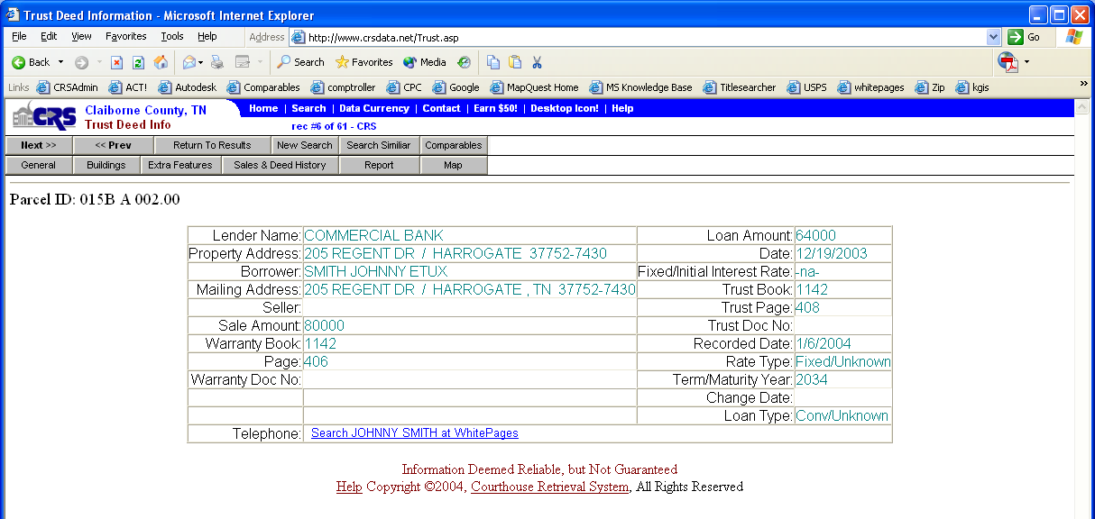

Mortgage information for the property is on this screen.

New Search – takes you back to search options screen.
Report – generates a full report on the property.
Return to Results – returns you to the Search Results Screen.
Map – if you have acquired a CRS CD MAP-begins the CRS Map Program. (See separate User’s Guide)

SIMILAR PROPERTIES SEARCH SCREEN
The Similar Search Screen can be accessed from any search results screen.

This is the Search Similar Screen:
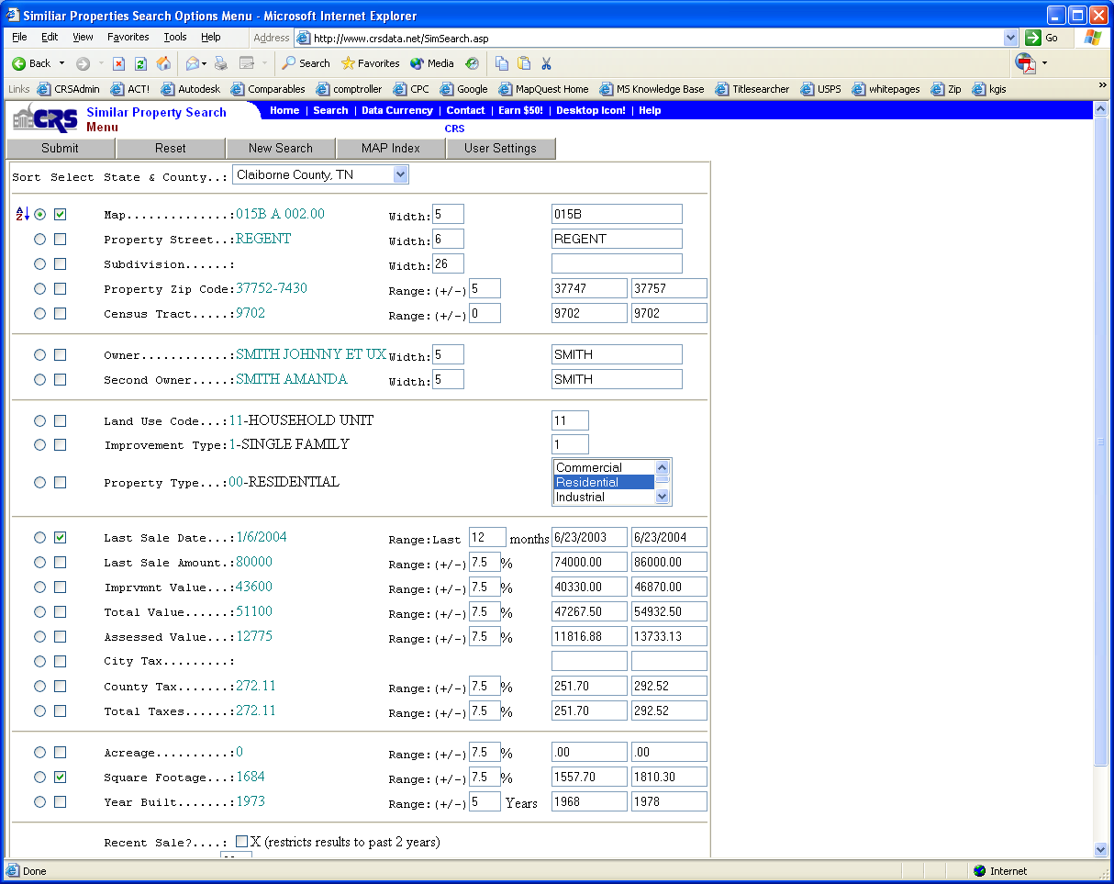

The screen contains information from the viewed property to make it easier for you to find properties that are similar to the subject property. This screen is a lot like the Property Search Menu. The Sort button work the same way. Remember-you can sort on a field without including that field in your search criteria. The box between the sort button and the field name is the Selection Box. By clicking this box you choose to include the corresponding field in your search. Since the search information was filled in for you automatically, you can just check the fields you want to base the search on and click Submit.

You can also change the search information that was automatically placed in your search if it is not exactly what you are looking for. Just click in the information area and modify the search criteria to your satisfaction.

Changing the “WIDTH” or “RANGE” for a field…
Once you type in a new width or percentage hit your TAB button on your keyboard to see the new search criteria.
(You can also do this by clicking in another area of the web page with your mouse)

If a piece of information was not available in the viewed property, then the range or width for that property will not appear on this screen. You can however, include values of your choice for these fields if necessary.

REMEMBER – IF THE BOX IS NOT CHECKED, THAT PIECE OF INFORMATION WILL NOT BE CONSIDERED IN THE SEARCH.

PRINTING/EXPORTING PROPERTY INFORMATION AND LABELS

REPORTS

- Printing reports can be done from three places in the CRS program.
- From the Search Results Screen, click on Full Report button for a record.
- Clicking the Print Marked button after marking records on the Results screen.

Once you select the Report, the report will show on your screen. To print this, click on the File menu at the top of the window, and select Print.

NOTE: Make sure you see “DONE” in the status bar at the bottom of your Internet Explorer window before you select print. The first page of the report may appear on your screen before the report is completely finished generating.

LABELS and EXPORTING

To print labels choose the “Labels” button. This will give you the following screen:

Options For Exporting Records/ Printing Labels

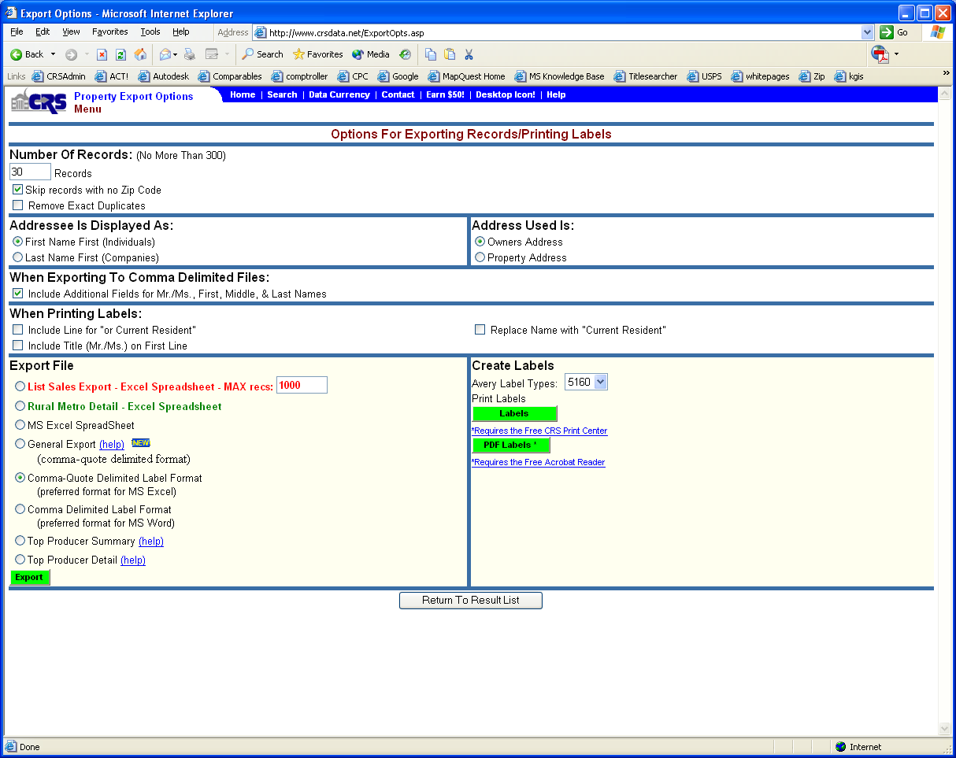

This screen provides you with options for printing labels or exporting label information.

Number of Records – Choose how many records you want to print labels for. You can print up to 300 at a time. Just enter the number in the box. NOTE: If you have marked records, the number of marked records will show here instead.

Skip Records with No Zip Code – Check here to eliminate records with incomplete addresses.

Remove Exact duplicates – Check here to eliminate records that are exactly the same.

Address Is Displayed As – Choose to have the name print First Name first or Last Name first. If your records primarily contain personal names choose First Name first. If your list is mostly company names, choose Last Name first.

Address Used Is – Choose to print the owner address or property address on the labels.

When Exporting to Comma delimited Files - You have the option to Include additional fields for Mr/Mrs., First, Middle, & Last Names. Check the box if you would like to export these fields.

When Printing Labels - You have the option to Include Line for "OR CURRENT RESIDENT" and to Include Title (Mr./Ms.) on the First Line.
Put a check mark in the desired boxes.

Export File select which format you want the export file to be in. (Some formats may not be available)
A. MS Excel SpreadSheet
B. Comma-Quote Delimited Label (preferred for MS Excel) - select if you are going to import to Excel
C. Comma Delimited Label (preferred for MS Word) - select if you are going to import to Word 2000 and up
D. Top Producer Summary - select if importing to Top Producer - 22 fields
E. Top Producer Detail - select if importing to Top Producer - 87 fields
Click the Export button (green button)
The text data page will open.
The data will look something like this:
"Name","Address","City","State","Zip","FirstName","MiddleName","LastName","Title"
"James Smith","PO Box 4386","Greensboro","NC"," 274044386","James","Norman & Debra","Smith","Mr."
"James N Smith","409 Blanchwood Ave","Greensboro","NC","27401","James","N.","Smith","Mr."

Create Labels select the type of label paper you have.
5160 - contains 30 labels on a page. 3 across and 10 down.
5162 - contains 14 labels on a page. 2 across and 7 down.
Click one of the green labels button. Depending on which one you click you must have the appropriate software installed.
Labels - requires the Free CRS Print Center
PDF Labels - requires the Free Adobe Acrobat Reader
Follow one of the set of instructions below:
A. LABELS - In the File Download window that opens, select the Open option.
CRS Print Center will open, click the Print button to send the labels to the printer.
NOTE: To change the starting label, click the Labels tab. Click the Set Starting Label button and click once on the label position desired.
OR
B. PDF LABELS - Click in the circle for the desired starting label. (Starting Label is the first label that will be printed on) Click the green OK button.
Adobe Acrobat Reader will open and the labels will come up on the screen. Click File then Print

If you choose to export the information, the data will display on your screen. You can then choose to print it or save it from your browser. Usually you will find the print and save options on the FILE MENU of the browser.

USING THE EXPORT INFORMATION WITH OTHER APPLICATIONS

If you would like to use the name and address information from CRS to create form letters, contact records, special labels, etc in other windows applications, here are your steps for some commonly used applications.

CRS - How to Mail Merge using Word 2000
HOWTO
1. Export the data from our system.
2. Open Word 2000 and type the letter. If you already have a letter typed open it.
3. Click on Tools then Mail Merge. The Mail Merge Helper window will open.
4. Under 1 Main Document click the Create button and select Form Letters.
5. In the pop-up window select the button on the left. It will either say Active Window or Change Document Type.
6. Under 2 Data Source click the Get Data button and select Open Data Source.
7. In the Open Data Source window select the location in Look in where you saved your data file (list of names and addresses you saved from CRS web site). Under Files of Type select All Files(*.*). Double-click the data file (list of names and addresses you saved from CRS web site) you want to use.
NOTE: If a Confirm Data Source window opens click OK.
8. In the pop-up window click Edit Main Document.
If a pop-up window does not appear and you already have
<<Name>>
<<Address>>
<<City>>, <<State>> <<Zip>>
in your letter skip to step 12, otherwise click the Close button.
9. Position your cursor on the letter where you want the data field to go.
10. Click the Insert Merge Field button at the top of the screen and select the field you want to be in the letter.
Repeat steps 9 and 10 until you have inserted all the fields you want in your letter.
The field layout will look like:
<<Name>>
<<Address>>
<<City>>, <<State>> <<Zip>>
11. Click on Tools then Mail Merge. The Mail Merge Helper window will open.
12. Under 3 Merge the data with the document click the Merge button.
13. In the pop-up window click Merge.
14. A new document window will open named Form Letters1. You might see a pop-up window that says Record # was an empty record, click OK. If you still see the orginal letter with the field names, look at the bottom of your monitor for another Word window named Form Letters1 and click on it.
15. To Print the Letters: In the Form Letters1 document click File then Print.
To Save the Letters: In the Form Letters1 document click File then Save As.
NOTE:To save the orginal letter click on it at the bottom of your monitor. Select File then Save

CRS - How to Mail Merge using Word XP
HOWTO
1. Export the data from our system.
2. Open Word XP and type the letter. If you already have a letter typed open it now.
3. Click on Tools then Letters and Mailings then Mail Merge Wizard. The Mail Merge window will open on the right side of the screen.
4. Under Select document type select Letters. Click Next: Starting document at the bottom of the screen.
5. Under Select starting document select Use the current document. Click Next: Select recipients at the bottom of the screen.
6. Under Select recipients select Use an existing list. Under Use an existing list click on Browse.
7. In the Select Data Source window select the Location where you saved your data file (list of names and addresses you saved from CRS web site). Under Files of type: select All Files. Double-click the data file (list of names and addresses you saved from CRS web site) you want to use.
In the Mail Merge Recipients window you can edit, add, or remove any data. When finished click the OK button.
Click Next: Write your letter at the bottom of the screen.
8. Position your cursor on the letter where you want the name and address to go.
9. Click Address block. In the Insert Address Block window select how you want the name and address to appear. Click OK. In your letter you will see <<Address Block>> which represents the name and address fields.
Click Next: Preview your letters at the bottom of the screen.
10. Under Preview your lettersyou can click the double arrow buttons to view each letter. NOTE: If you want to remove a name, you can click Exclude this recipient.
Click Next: Complete the merge at the bottom of the screen.
11. Under Complete the merge click one of two options:
Print... sends the letters directly to the printer
OR
Edit individual letters... opens another window with the letters as a new document
12. In the Merge to window select which records you want to merge. Click OK
13. If you selected to Edit individual letters..., after you finish making changes click File then Print.
NOTE:To save the orginal letter click on it at the bottom of your monitor. Select File then Save.

CRS - How to Import into Excel
HOWTO
1. Export the data from our system.
2. Open Excel. Click File then Open. Select the Location where you saved your data file. Under Files of type: select All Files. Double-click the data file you want to use.
3. In the Text Import Wizard - Step 1 of 3 select Delimited and click Next.
4. In the Text Import Wizard - Step 2 of 3 uncheck Tab and put a check beside Comma. Click Next.
5. In the Text Import Wizard - Step 3 of 3 do not change any settings and click Finish.
6. The data should appear in your Excel window. To save this page click File then Save As.
7. Select the location you want to Save in and give the file a name. Under Save as type select Microsoft Excel Workbook(*.xls). Click Save.

CRS - Can I import data into Top Producer 7i?
Question: Can I import data into Top Producer 7i?
Answer: Yes, but you will need to change the file format from .TXT to .CSV
Changing file format from .TXT to .CSV
1. After you have exported the data file from CRS website, you will need to make sure you are able to edit the file extensions.
Click your Start button and go to Settings then Control Panel.
2. Double-click the icon for Folder Options. If there is not an icon click View then Folder Options from the toolbar.
3. Click the View tab. Under Advanced settings: uncheck Hide file extensions for known file types. Click OK.
NOTE: If it is already unchecked click Cancel.
4. Close the Control Panel.
5. Go to the location where you saved the data file.
6. Right click the icon for the file and select Rename.
7. Replace .txt with .csv and press Enter. The file is now ready to import into Top Producer 7i. NOTE: If you have trouble with these instructions, please visit Top Producer's website at http://www.topproducer.com/convert.html for other data conversion options.

TIPS FOR SORTING & SEARCHING

- Sort and Search are independent of each other, for example, you may search for all property in a subdivision but sort by owner’s name. You do not have to complete the sort field. If you do not select a sort field, THEN the data is sorted by Parcel ID.

- You can complete any or all fields. However, the more specific your search criteria (the more fields completed), the faster the search results are reported. This occurs because as more fields are completed it helps the search engine to eliminate data resulting in a faster search because there is a smaller group of records to search through.

- The search fields are not case sensitive.

- To open multiple screens to compare properties:

- Select FILE from the toolbar.
- Click NEW from the drop down menu.
- Type search and sort parameters.

- The Wildcard search allows you to search for an owner, subdivision or address even if you are not sure of the exact spelling. For example, typing _OLE, in the owner’s name provides all property owner’s names that are variations of this spelling such as Kole, or Cole. The wild card search is applicable in the following text fields:

- Owner 1
- Owner 2
- Mailing Address
- Property Address
- Subdivision

Example of using Wildcard search in an address:
Need to look at properties that lie within a street block. Entering 114_ _ would give you the 11400 block of the street you select. (any property with the street number of 11400 through 11499).

- When using the Mortgage Search Menu, keep in mind that there are many trust deeds that have not been matched to a parcel id because there was not enough information on the actual trust deed to make a match. To skip past these unmatched trust deeds, you can use the wildcard character. By placing the wildcard character “_” in the parcel id field, the results will only include matched trust deeds.

TECHNICAL SUPPORT

At Courthouse Retrieval System, Inc. your needs are our top priority. Should you have any questions, suggestions, or comments, we are eager to hear from you.

For technical support, call (865) 584-8017 (Knoxville, TN metro area) or toll free (800) 374-7488.
We can also be reached by email at getTechSupport@crsdata.com.

Please let us know all information about the problem you are having, including:

Any error codes.
Description of problem.
Any recent changes to your computer.

